**SMART ROOM AUTOMATION**

**SYSTEM**

Mini Project Report

By

Shiv Shikhar Sinha

Ritik Kumar Yadav

Hrishitosh Thakur

Anushka Agarwal

Vikram Thakur

Parna Jain

Under the guidance of

Ms. Aditee Mattoo

Assistant Professor

Department of Computer Science & Engineering (IoT)



Noida Institute of Engineering & Technology

Plot- 19, Knowledge Park II, Greater Noida-201310

**CERTIFICATE**

**TO WHOM IT MAY CONCERN**

The undersigned certify that they have read and recommended to the Department of Computer Science and Engineering (IoT), Noida Institute of Engineering & Technology, a project work entitled “Smart Classroom Automation System” submitted by Shiv Shikhar Sinha, Hrishitosh Thakur, Ritik Kumar Yadav, Anushka Agarwal, Parna Jain & Vikram Thakur during the academic year 2021-2022 and that this project has not been submitted previously.

_______________________

Ms. Aditee Mattoo

Assistant Professor

Department of Computer Science   
& Engineering (IoT)

**ACKNOWLEDGEMENT**

We express our sincere gratitude to Ms. Aditee Mattoo, Assistant Professor, Department of Computer Science & Engineering (IoT), Noida Institute of Engineering & Technology, as our mentor for the project. It is our great fortune that we have got opportunity to carry out this project work under the supervision. We express our sincere thanks for the encouragement, support, and the guidance. We would further like to thank all the faculty member for their cooperation and extended support in undergoing the project work. We also would thank the Department of Computer Science & Engineering (Internet of Things) to provide the infrastructure and facility in carrying the projects like these.

Shiv Shikhar Sinha Ritik Kumar Yadav Hrishitosh Thakur Anushka Agarwal Vikram Thakur Parna Jain

B. Tech CSE (IoT) – 4th Semester, 2022, NIET

**CONTENTS**

**Topics**

**1. Introduction**

1.1 Introduction

1.2 Background

1.3 Project Objective

1.4 Scope

1.5 Project Management

1.6 Overview and Benefits

**2. Literature Review**

**3. Theory**

3.1 Internet of Things (IoT)

3.1.1 Features of IoT

3.1.2 Advantages of IoT

3.1.3 Application grounds of IoT

3.1.4 IoT Technologies and Protocols

3.1.5 IoT Software

**4. Hardware Modelling and Setup**

4.1 Main features of the prototype

4.2 Project Layout

4.3 Components Requirement

4.4 Setting up the system

**5. Logic and Operation**

5.1 Flow Chart

5.2 Principle and Operation

5.2.1 Advantage of Node MCU

5.3 Blynk Application

5.4 Wireless Communication Network

5.5 Voice Mode Control

**6. Conclusion and Future Scopes**

6.1 Result

6.2 Limitation

6.3 Further Enhancement and Future Scopes

6.4 Conclusion

**7. References**

**Appendix A Hardware Description**

**Appendix B Data Sheets**

**ABSTRACT**

With the new technologies being introduced in the market, automation is the need of the hour. Due to the discovery of Internet of Things (IoT), there has been a vast increase in applications which do not require human to human or human to computer interactions. This paper demonstrates the use of Internet of Things to automate the working of lights and fans of the classroom for energy efficient usage of resources. We have used Node MCU and Arduino, popular open source IoT platforms for the system to be self-operating. The main control system implements wireless technology to provide remote access from smart phone. We have used sensors like PIR and ultrasonic sensor to detect human presence in classroom and accordingly adjust the lights and fans of the class. The system is user friendly, flexible and can be advanced with new features in future. In this paper, efforts are being made to minimize human effort, conserve electrical energy, and enable remote access.

**INTRODUCTION**

* 1. **INTRODUCTION**

In today’s era, energy efficient devices are the need of the time. We humans are wasting too much electricity by not turning of the lights and fans in our class. The people don’t even pay attention to unnecessary usage of electrical energy. So, we need a smart system to control the functioning of the lights and fans according to the requirement in the room. The system is based upon IoT.

Internet of Things (IoT) has made the technology development evolve swiftly. IoT is used to control devices and systems from anywhere using Internet. It acts as a platform to transfer data between computing devices. IoT can also make use of artificial intelligence and machine learning [2] to make data collecting processes easier and more dynamic. Using new wireless technologies like Bluetooth and Wi-Fi, different devices have capability to connect with each other.[3]

Due to the advancement of wireless technology, there are several different types of connections are introduced such as GSM, WIFI, and BT. Each of the connection has their own unique specifications and applications. Among the four popular wireless connections that often implemented in project, WIFI is being chosen with its suitable capability. The capabilities of WIFI are more than enough to be implemented in the design. Also, most of the current laptop/notebook or Smartphone come with built-in WIFI adapter. It will indirectly reduce the cost of this system.

­­­­

* 1. **BACKGROUND**

The concept of “Smart Classroom Automation” has been in existence for several years. “Smart Classroom”, “Intelligent room” are terms that followed and has been used to introduce the concept of networking appliance within the house. Smart Classroom Automation Systems (SCASs) includes centralized control and distance status monitoring of lighting, security system, and other appliances and systems within a classroom. SCASs enables energy efficiency, improves the security systems, and certainly the comfort and ease of users. In the present emerging market, SCASs is gaining popularity and has attracted the interests of many users. SCASs comes with its own challenges. Mainly being, in the present day, end users especially elderly and disabled, even though hugely benefited, aren’t seen to accept the system due to the complexity and cost factors.

* 1. **PROJECT OBJECTIVES**

**Design of an independent Automation System**

To formulate the design of an interconnected network of “things” to be integrated into the system. The objective to account for every appliance and its control to be automated and integrated into the network further formulated into the system.

**Wireless control of appliances (Switch and Voice mode)**

To develop the application that would include features of switch and/or voice modes to control the applications.

**Monitoring status of appliances**

Being able to view the status of appliances on the application, in order have a better Automated environment.

**Secure connection channels between application and Node MCU**

Use of secure protocols over Wi-Fi so that other devices are prevented to achieve control over the Automated System. Secure connections are obtained by SSL over TCP, SSH.

**Controlled by any device capable of Wi-Fi (Android, iOS, PC)**

To achieve flexibility in control of the home appliances, and device capable of Wi-Fi connectivity will be able to obtain a secure control on the Automated System.

**Extensible platform for future enhancement**

With a strong existing possibility of adding and integrating more features and appliances to the system, the designed system needs to be highly extensible in nature.

* 1. **SCOPE**

The aim is to design a prototype that establishes wireless remote control over a network of home appliances. The application is designed to run on android device providing features like, switch mode control, voice command control and a provision to view the status of the devices on the application itself. Considering its wide range of application, following are the scope of this prototype. The system can be implemented in classrooms, schools, small institutes, and colleges as well, being in-charge of control of the electrical appliances. For remote access of appliances in internet or intranet. The appliances in the above-mentioned environment can be controlled in intra-network or can be accessed via internet. The development of technology friendly environment. The system incorporates the use of technology and making Automated System. Using day-to-day gadgets, we can utilize them for a different perspective.

* 1. **PROJECT MANAGEMENT**

Management of any project can be briefly disintegrated into several phases. Our project has been decomposed into the following phases:

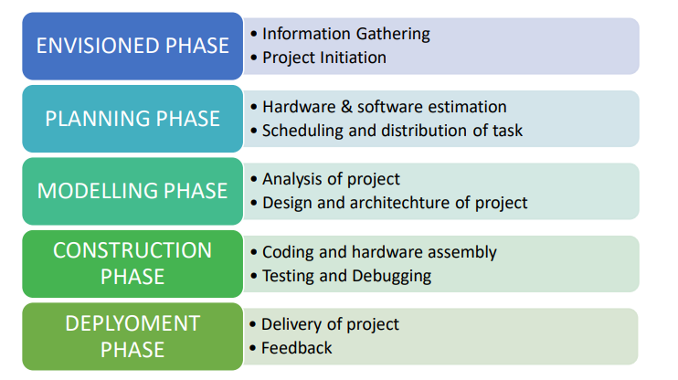

**Experimentation**

This phase involved discussions regarding necessary equipment regarding the project. The study of related already existing projects, gathering required theoretical learning. It also included figuring out the coding part, by developing simple algorithms and flowcharts to design the whole process.

**Design**

This phase was, designing layout of the application, and the necessary features to be included. This involved the complete hardware assembly and installing the code to Node MCU. The power strip was designed to connect the home appliances that can be controlled via GPIO pins.

**Development and testing**

This phase had the development of the application. The android device was connected to the Node MCU via wireless network (Wi-Fi) and the whole prototype was tested for identification and removal of bugs.

**Real world testing**

The prototype was ready to be tested into the real world and integrated with various real time electrical appliances.

* 1. **OVERVIEW AND BENEFITS**

The benefits of an established wireless remote switching system of appliances include:

**No legal issues**

Obtaining access to or traversing properties with hard lines is extremely difficult.

**Reduced wiring issues**

Considering the increase in price of copper, thus increases the possibility of the wire to be stolen. The use of a wireless remote system to control appliances means no wire for thieves to steal.

**Extended range**

As the system establishes control over Wi-Fi, it was a generally considered descent range. That is 150 feet indoors. Outdoors it can be extended to 300 feet, but since the application is of a HAS, an indoor range is considered.

**Security**

As the connection of the control of the system is established over a secure network the system ensures security to the maximum extent.

**Integrable and extensive nature**

The prototype designed can be integrated to a larger scale. Also, it has an extensive nature being able to add or remove the appliances under control according to application.

**LITERATURE REVIEW**

|  |  |  |  |  |
| --- | --- | --- | --- | --- |
| SNO. | AUTHOR | TITLE | SOURCE | FINDINGS |
| 1 | Nazwa Nasuha | A Design of Smart IoT-Based College Room Using Arduino | Journal of Physics, Conference series | Project’s design and development is based on IoT by  implementation of Arduino. The project applies Arduino MEGA 2560 board in conjunction with  ATmega2560 chip.[1] |
| 2 | Soumyajit Mitra | Smart Light for Home with Automatic Direction and Intensity Adjustment using Arduino | International Journal of Recent Technology and Engineering (IJRTE) | The system uses a series of sensors to track human movement in a confined space and focus more light in that direction. Also the system has the ability to adapt the intensity and number of lights based on number of people in the room***.***[2] |
| 3 | Shivani Jadon | Comfy Smart Home using IoT | International Conference on Innovative Computing and Communication (**ICICC**-**2020**) | Iot is used to connect various devices and describes the working of face recognition systems using machine learning and it can be embedded in security locks.[3] |
| 4 | Deny Nusyirwan, Arnav Choudhary,Himanshu Saini, Utkarsh Dua, Nikhil Sharma | Engineering Design Process of Arduino Uno based Smart Classroom Technology | Journal of Innovation and Technology | This research is a form of higher education contribution in improving student learning outcomes in elementary schools, through the provision of facilities in classrooms. Technology in schools is one of the driving forces for advancing education in schools and is expected to be able to change the mindset of students.[4]   |  | | --- | |  | |
| 5 | Ravi Wankhade, Shashank Karhade, Pratik Mohite, Kanchan Dhole, Akash Ganvir, Bharti Khedkar | Home Automation System based on IoT using cellular devices | IJSRST 2019 | Designed an  easy and a secure system to regulate home appliances  particularly aimed to help elders and disabled.[5] |

**THEORY**

**3.1 IOT (INTERNET OF THINGS)**

IOT as a term has evolved long way as a result of convergence of multiple technologies, machine learning, embedded systems and commodity sensors. IOT is a system of interconnected devices assigned a UIDS, enabling data transfer and control of devices over a network. It reduced the necessity of actual interaction to control a device. IOT is an advanced automation and analytics system which exploits networking, sensing, big data, and artificial intelligence technology to deliver complete systems for a product or service. These systems allow greater transparency, control, and performance when applied to any industry or system.

**3.1.1 Features of IOT**

**3.1.1.1 Intelligence**

IOT comes with the combination of algorithms and computation, software & hardware that makes it smart. Ambient intelligence in IOT enhances its capabilities which facilitate the things to respond in an intelligent way to a particular situation and supports them in carrying out specific tasks. Despite all the popularity of smart technologies, intelligence in IOT is only concerned as a means of interaction between devices, while user and device interaction are achieved by standard input methods and graphical user interface.

**3.1.1.2 Connectivity**

Connectivity empowers the Internet of Things by bringing together everyday objects. Connectivity of these objects is pivotal because simple object level interactions contribute towards collective intelligence in the IOT network. It enables network accessibility and compatibility in the things. With this connectivity, new market opportunities for the Internet of things can be created by the networking of smart things and applications.

**3.1.1.3 Dynamic Nature**

The primary activity of Internet of Things is to collect data from its environment, this is achieved with the dynamic changes that take place around the devices. The state of these devices changes dynamically, example sleeping and waking up, connected and/or disconnected as well as the context of devices including temperature, location and speed. In addition to the state of the device, the number of devices also changes dynamically with a person, place, and time.

**3.1.1.4 Enormous Scale**

The number of devices that need to be managed and that communicate with each other will be much larger than the devices connected to the current Internet. The management of data generated from these devices and their interpretation for application purposes becomes more critical. Gartner (2015) confirms the enormous scale of IOT in the estimated report where it stated that 5.5 million new things will get connected every day and 6.4 billion connected things will be in use worldwide in 2016, which is up by 30 percent from 2015. The report also forecasts that the number of connected devices will reach 27.1 billion by 2025.

**3.1.1.5 Sensing**

IOT wouldn’t be possible without sensors that will detect or measure any changes in the environment to generate data that can report on their status or even interact with the environment. Sensing technologies provide the means to create capabilities that reflect a true awareness of the physical world and the people in it. The sensing information is simply the analog input from the physical world, but it can provide a rich understanding of our complex world.

**3.1.1.6 Heterogeneity**

Heterogeneity in Internet of Things as one of the key characteristics. Devices in IOT are based on different hardware platforms and networks and can interact with other devices or service platforms through different networks. IOT architecture should support direct network connectivity between heterogeneous networks. The key design requirements for heterogeneous things and their environments in IOT are scalabilities, modularity, extensibility, and interoperability.

**3.1.1.7 Security**

IOT devices are naturally vulnerable to security threats. As we gain efficiencies, novel experiences, and other benefits from the IOT, it would be a mistake to forget about security concerns associated with it. There is a high level of transparency and privacy issues with IOT. It is important to secure the endpoints, the networks, and the data that is transferred across all of it means creating a security paradigm.

**3.1.2 Advantages of IOT**

**3.1.2.1 Communication**

IOT encourages the communication between devices, also famously known as Machine-to-Machine (M2M) communication. Because of this, the physical devices can stay connected and hence the total transparency is available with lesser inefficiencies and greater quality.

**3.1.2.2 Automation and Control**

Due to physical objects getting connected and controlled digitally and centrally with wireless infrastructure, there is a large amount of automation and control in the workings. Without human intervention, the machines can communicate with each other leading to faster and timely output.

**3.1.2.3 Information**

It is obvious that having more information helps making better decisions. Whether it is mundane decisions as needing to know what to buy at the grocery store or if your company has enough widgets and supplies, knowledge is power and more knowledge is better.

**3.1.2.4 Monitor**

The second most obvious advantage of IOT is monitoring. Knowing the exact quantity of supplies or the air quality in your home, can further provide more information that could not have previously been collected easily. For instance, knowing that you are low on milk or printer ink could save you another trip to the store soon. Furthermore, monitoring the expiration of products can and will improve safety.

**3.1.2.5 Time**

As hinted in the previous examples, the amount of time saved because of IOT could be quite large. And in today’s modern life, we all could use more time.

**3.1.2.6 Money**

The biggest advantage of IOT is saving money. If the price of the tagging and monitoring equipment is less than the amount of money saved, then the Internet of Things will be very widely adopted. IOT fundamentally proves to be very helpful to people in their daily routines by making the appliances communicate to each other in an effective manner thereby saving and conserving energy and cost. Allowing the data to be communicated and shared between devices and then translating it into our required way, it makes our systems efficient.

**3.1.2.7 Automation of daily tasks leads to better monitoring of devices**

The IOT allows you to automate and control the tasks that are done daily, avoiding human intervention. Machine-to-machine communication helps to maintain transparency in the processes. It also leads to uniformity in the tasks. It can also maintain the quality of service. We can also take necessary action in case of emergencies.

**3.1.2.8 Efficient and Saves Time**

The machine-to-machine interaction provides better efficiency, hence; accurate results can be obtained fast. This results in saving valuable time. Instead of repeating the same tasks every day, it enables people to do other creative jobs.

**3.1.2.9 Saves Money**

Optimum utilization of energy and resources can be achieved by adopting this technology and keeping the devices under surveillance. We can be alerted in case of possible bottlenecks, breakdowns, and damages to the system. Hence, we can save money by using this technology.

**3.1.2.10 Better Quality of Life**

All the applications of this technology culminate in increased comfort, convenience, and better management, thereby improving the quality of life.

**3.1.3 Disadvantages of IOT**

**3.1.3.1 Compatibility**

Currently, there is no international standard of compatibility for the tagging and monitoring equipment. I believe this disadvantage is the easiest to overcome. The manufacturing companies of these equipment just need to agree to a standard, such as Bluetooth, USB, etc. This is nothing new or innovative needed.

**3.1.3.2 Complexity**

As with all complex systems, there are more opportunities of failure. With the Internet of Things, failures could skyrocket. For instance, let’s say that both you and your spouse each get a message saying that your milk has expired, and both of you stop at a store on your way home, and you both purchase milk. As a result, you and your spouse have purchased twice the amount that you both need. Or maybe a bug in the software ends up automatically ordering a new ink cartridge for your printer each and every hour for a few days, or at least after each power failure, when you only need a single replacement.

**3.1.3.3 Privacy/Security**

With all this IOT data being transmitted, the risk of losing privacy increases. For instance, how well encrypted will the data be kept and transmitted with? Do you want your neighbours or employers to know what medications that you are taking or your financial situation?

**3.1.3.4 Safety**

Imagine if a notorious hacker changes your prescription. Or if a store automatically ships you an equivalent product that you are allergic to, or a flavour that you do not like, or a product that is already expired. As a result, safety is ultimately in the hands of the consumer to verify any and all automation. As all the household appliances, industrial machinery, public sector services like water supply and transport, and many other devices all are connected to the Internet, a lot of information is available on it. This information is prone to attack by hackers. It would be very disastrous if private and confidential information is accessed by unauthorized intruders.

**3.1.3.5 Lesser Employment of Menial Staff**

The unskilled workers and helpers may end up losing their jobs in the effect of automation of daily activities. This can lead to unemployment issues in the society. This is a problem with the advent of any technology and can be overcome with education. With daily activities getting automated, naturally, there will be fewer requirements of human resources, primarily, workers and less educated staff. This may create Unemployment issue in the society.

**3.1.3.6 Technology Takes Control of Life**

Our lives will be increasingly controlled by technology and will be dependent on it. The younger generation is already addicted to technology for every little thing. We must decide how much of our daily lives are we willing to mechanize and be controlled by technology.

**3.1.4 Application Grounds of IOT**

**3.1.4.1 Wearables** Wearable technologies are a hallmark of IOT applications and is one of the earliest industries to have deployed IOT at its services. Fit Bits, heart rate monitors, smartwatches, glucose monitoring devices reflect the successful applications of IOT.

**3.1.4.2 Smart homes**

This area of application concerned to this project, so a detailed application is discussed further. Jarvis, an AI home automation employed by Mark Zuckerberg, is a remarkable example in this field of application.

**3.1.4.3 Health care**

IOT applications have turned reactive medical based system into proactive wellness-based system. IOT focuses on creating systems rather than equipment. IOT creates a future of medicine and healthcare which exploits a highly integrated network of sophisticated medical devices. The integration of all elements provides more accuracy, more attention to detail, faster reactions to events, and constant improvement while reducing the typical overhead of medical research and organizations.

**3.1.4.4 Agriculture**

A greenhouse farming technique enhances the yield of crops by controlling environmental parameters. However, manual handling results in production loss, energy loss, and labour cost, making the process less effective. A greenhouse with embedded devices not only makes it easier to be monitored but also, enables us to control the climate inside it. Sensors measure different parameters according to the plant requirement and send it to the cloud. It, then, processes the data and applies a control action.

**3.1.4.5 Industrial Automation**

For a higher return of investment this field requires both fast developments and quality of products. This vitality thus coined the term IIOT. This whole schematic is re-engineered by IOT applications.

Following are the domains of IOT applications in industrial automation

• Factory Digitalization

• Product flow Monitoring

• Inventory Management

• Safety and Security

• Quality Control

• Packaging optimization

• Logistics and Supply Chain Optimization

**3.1.4.6 Government and Safety**

IOT applied to government and safety allows improved law enforcement, defence, city planning, and economic management. The technology fills in the current gaps, corrects many current flaws, and expands the reach of these efforts. For example, IOT can help city planners have a clearer view of the impact of their design, and governments have a better idea of the local economy.

**3.1.5 IOT Technologies and Protocols**

Several communication protocols and technologies cater to and meet the specific functional requirements of IOT system.

**3.1.5.1 Bluetooth**

Bluetooth is a short range IOT communication protocol/technology that is profound in many consumers product markets and computing. It is expected to be key for wearable products in particular, again connecting to the IOT albeit probably via a smartphone in many cases. The new Bluetooth Low-Energy (BLE) – or Bluetooth Smart, as it is now branded – is a significant protocol for IOT applications. Importantly, while it offers a similar range to Bluetooth it has been designed to offer significantly reduced power consumption.

**3.1.5.2 Zigbee**

ZigBee is similar to Bluetooth and is majorly used in industrial settings. It has some significant advantages in complex systems offering low-power operation, high security, robustness and high and is well positioned to take advantage of wireless control and sensor networks in IOT applications. The latest version of ZigBee is the recently launched 3.0, which is essentially the unification of the various ZigBee wireless standards into a single standard.

**3.1.5.3 Z-Wave**

Z-Wave is a low-power RF communications IOT technology that primarily design for home automation for products such as lamp controllers and sensors among many other devices. A ZWave uses a simpler protocol than some others, which can enable faster and simpler development, but the only maker of chips is Sigma Designs compared to multiple sources for other wireless technologies such as ZigBee and others.

**3.1.5.4 Wi-Fi**

Wi-Fi connectivity is one of the most popular IOT communication protocol, often an obvious choice for many developers, especially given the availability of Wi-Fi within the home environment within LANs. There is a wide existing infrastructure as well as offering fast data transfer and the ability to handle high quantities of data. Currently, the most common Wi-Fi standard used in homes and many businesses is 802.11n, which offers range of hundreds of megabits per second, which is fine for file transfers but may be too power consuming for many IOT applications.

**3.1.5.5 Cellular**

Any IOT application that requires operation over longer distances can take advantage of GSM/3G/4G cellular communication capabilities. While cellular is clearly capable of sending high quantities of data, especially for 4G, the cost and power consumption will be too high for many applications. But it can be ideal for sensor-based low-bandwidth-data projects that will send very low amounts of data over the Internet.

**3.1.5.6 NFC**

NFC (Near Field Communication) is an IOT technology. It enables simple and safe communications between electronic devices, and specifically for smartphones, allowing consumers to perform transactions in which one does not have to be physically present. It helps the user to access digital content and connect electronic devices. Essentially it extends the capability of contactless card technology and enables devices to share information at a distance that is less than 4cm.

**3.1.5.7 LoRaWAN**

LoRaWAN is one of popular IOT Technology, targets wide-area network (WAN) applications. The LoRaWAN design to provide low-power WANs with features specifically needed to support low-cost mobile secure communication in IOT, smart city, and industrial applications. Specifically meets requirements for low-power consumption and supports large networks with millions and millions of devices, data rates range from 0.3 kbps to 50 kbps.

**3.1.6 IOT software**

IOT software addresses its key areas of networking and action through platforms, embedded systems, partner systems, and middleware. These individual and master applications are responsible for data collection, device integration, real-time analytics, and application and process extension within the IOT network. They exploit integration with critical business systems (e.g., ordering systems, robotics, scheduling, and more) in the execution of related tasks.

**3.1.6.1 Data Collection**

This software manages sensing, measurements, light data filtering, light data security, and aggregation of data. It uses certain protocols to aid sensors in connecting with real-time, machine-to-machine networks. Then it collects data from multiple devices and distributes it in accordance with settings. It also works in reverse by distributing data over devices. The system eventually transmits all collected data to a central server.

**3.1.6.2 Device Integration**

Software supporting integration binds (dependent relationships) all system devices to create the body of the IOT system. It ensures the necessary cooperation and stable networking between devices. These applications are the defining software technology of the IOT network because without them, it is not an IOT system. They manage the various applications, protocols, and limitations of each device to allow communication.

**3.1.6.3 Real-Time Analytics**

These applications take data or input from various devices and convert it into feasible actions or clear patterns for human analysis. They analyse information based on various settings and designs in order to perform automation-related tasks or provide the data required by industry.

**3.1.6.4 Application and Process Extension**

These applications extend the reach of existing systems and software to allow a wider, more effective system. They integrate predefined devices for specific purposes such as allowing certain mobile devices or engineering instruments access. It supports improved productivity and more accurate data collection.

**HARDWARE MODELLING & SETUP**

**4.1 MAIN FEATURES OF THE PROTOTYPE**

The features of the developed prototype are:

• The prototype establishes a wireless remote switching system of home appliances.

• The prototype uses Wi-Fi to establish wireless control, which gives an indoor range to about 150 feet.

• The command to switch on and off an appliance can be given from radio buttons on the application from one’s smartphone.

• There is also a provision developed to use voice commands on smartphone to remotely switch home appliances

• Any device capable of Wi-Fi connectivity can be used to control the prototype.

• The control over home appliances is obtained over secure connections, by SSL over TCP, SSH.

• Simple design easy to integrate into a verity of appliances and extend on further range.

• Displays the status of each appliance on the application in smartphone

• Cost effective.

**4.2 PROJECT LAYOUT**

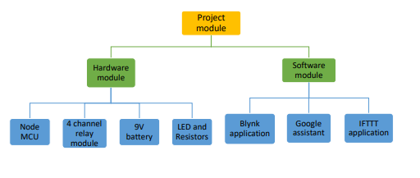

**Fig.- Layout of the Project Module**

**Node MCU** is the microcontroller unit in the prototype. It has an in built Wi-Fi module (ESP8266) that establishes wireless remote switching of home appliances.

**Four channel relay module** consists of 4 individual relays physically connected between Node MCU and the home appliances. It takes signals form GPIO pins of Node MCU and accordingly connects or disconnects home appliances from the supply. They act as the switching device.

**LED and resistors** are used in this prototype to replace real appliances. They indicate power being turned on and off to the appliances. In real time operation they would be replaced by actual home appliances.

**Blynk application** was designed for the Internet of Things. It can control hardware remotely, it can display sensor data, it can store data, visualize it, etc. the prototype primarily uses Blynk application to sense commands from user to the hardware over wireless network.

**Google assistant** is a system software present on the android phone. It interprets the voice commands by the user to turn on or off an appliance.

**IFTTT application** the voice commands interpreted by the google assistant isn’t understandable by Blynk application thus unable to send to the hardware. IFTTT is an intermediate application that interprets commands from Google assistant and sends on and off signal to Blynk application Via Blynk server.

**4.3 COMPONENTS REQUIRED**

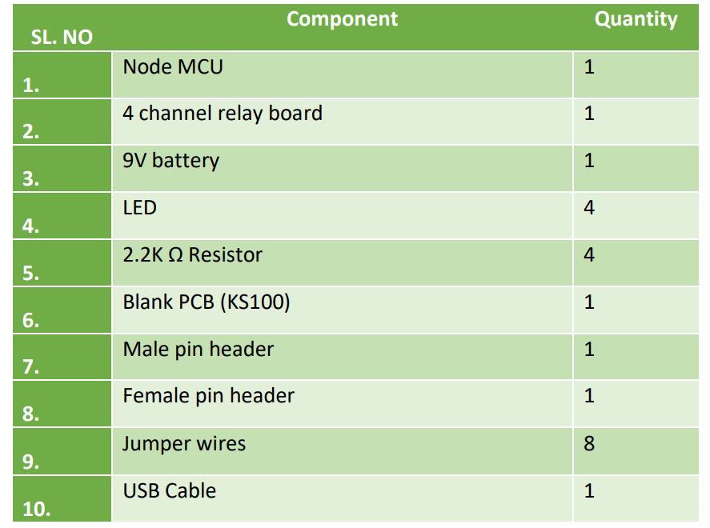

**Fig. - Component Listing**

**4.4 SETTING UP THE SYSTEM**

4.4.1 Downloading and installing and Blynk application on smartphone

* Blynk applicati on is downloaded and installed from the Play Store.
* Once the application is installed, a new account is created and logged in to it.
* After logging in, a new project is created. The project is named, hardware is selected as NodeMCU, and the connection type is selected as Wi-Fi and created.
* At this point Blynk will sends an authentication token to email id. This authentication token will be used to identify the hardware in the Blynk server.
* As the prototype uses 4 channel relay module, 4 buttons are added to the screen from the side bar. All the 4 buttons are then customised by adding a name and selecting the digital pin it will correspond to. This section will affect the hardware connection as the relays will be physically connected to the digital pins corresponded here.
* The setup of Blynk application is now complete.

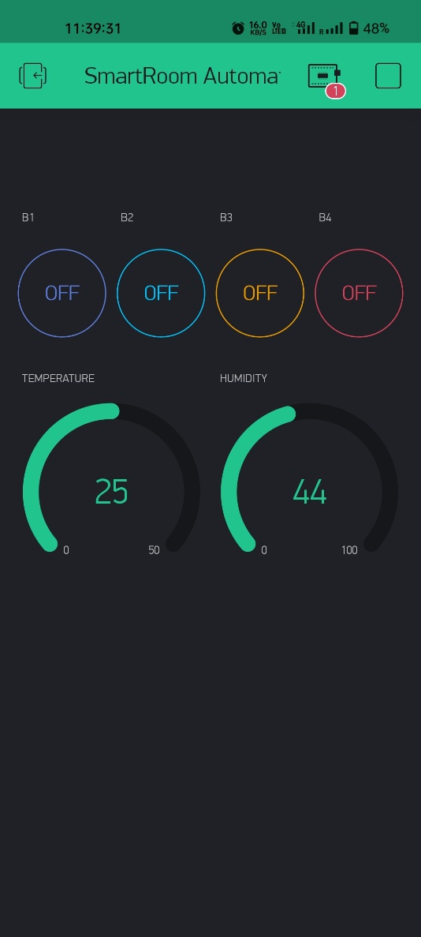

**Fig.- Setting up Blynk application**

**4.4.2 Driver installation for hardware interfacing**

Mostly these days devices download and install drivers on their own, automatically. Windows doesn’t know how to talk to the USB driver on the Node MCU so it can’t figure out that the board is a Node MCU and proceed normally.

* Node MCU Amica is an ESP8266 Wi-Fi module-based development board. It has got Micro USB slot that can directly be connected to the computer or other USB host devices. Ti has got 15X2 header pins and a Micro USB slot, the headers can be mounted on a breadboard and Micro USB slot is to establish connection to USB host device. It has CP2120 USB to serial converter.
* To install CP2120 (USB to serial converter), user is needed to download the driver for the same.
* Once user downloads drivers as per its respective operating system, the system establishes connection to Node MCU.
* The user needs to node down the COM post allotted to newly connected USB device (Node MCU) from device manager of the system. This com port number will be required while using Node MCU Amica.

**4.4.3 Interfacing Node MCU with Arduino IDE**

To begin with the latest Arduino IDE version, we’ll need to update the board manager with a custom URL. Open Arduino IDE and go to File > Preferences. Then, copy below URL into the Additional Board Manager URLs text box situated on the bottom of the window: <http://arduino.esp8266.com/stable/package_esp8266com_index.json>

* OK. Then navigate to the Board Manager by going to Tools > Boards > Boards Manager. There should be a couple new entries in addition to the standard Arduino boards. Filter your search by typing esp8266. Click on that entry and select Install.
* Before we get to uploading sketch & playing with LED, we need to make sure that the board is selected properly in Arduino IDE. Open Arduino IDE and select Node MCU 0.9 (ESP-12 Module) option under your Arduino IDE > Tools > Board menu.
* Now, plug your ESP8266 NodeMCU into your computer via micro-B USB cable. Once the board is plugged in, it should be assigned a unique COM port. On Windows machines, this will be something like COM#, and on Mac/Linux computers it will come in the form of /dev/tty.usbserial-XXXXXX. Select this serial port under the Arduino IDE > Tools > Port menu. Also select the Upload Speed: 115200

**4.4.4 Uploading code to Node MCU**

* NodeMCU is connected to PC using a USB cable.
* Now, we’ll set up the Arduino IDE by changing some settings. So, open up the Arduino IDE. Select Tools > Board and select ‘NodeMCU 1.0 (ESP-12E Module)’ as the board. And that’s all the settings we need to change. So now we begin writing the code.
* Select Files > Examples > Blynk > Boards_WIFI > ESP8266_Standalone. A new file with some prewritten code opens. The following changes to the code are made.

1. The line which says ‘char auth[] = “YourAuthToken”, replace YourAuthToken part with your Blynk’s authentication token that was generated by the Blynk server.
2. The line which says char ssid[] = “YourNetworkName”, replace YourNetworkName part with the name of Wi-Fi network that the Node MCU must connect to.
3. The line where it says char pass[] = “YourPassword” and replace the YourPassword part with the password of the Wi-Fi network.

• The code is ready to be uploaded to the hardware. On clicking upload button, the code is uploaded to Node MCU and the next time it’s powered on, it automatically connects to the assigned Wi-Fi network.

**4.4.5 Installation and setup of IFTTT**

* To configure IFTTT we visit their website https://ifttt.com and sign up using google account.
* After signing in, we select My Applets from header, and select New. Search for Google assistant and connect. Allow IFTTT for permission to use Google account to add voice commands to it.
* Configure the application to work as desired and Create Trigger.
* Select webhooks that will allow to send commands to Blynk server. Add http://188.166.206.43/ YourAuthTokenHere / update / DigitalPinToBeUpdateHere to the URL field.
* YourAuthTokenHere is replaced by the authentication token generated by Blynk server. DigitalPinToBoUpdatedHere is replaced by the digital pin of Arduino that corresponds to the Node MCU rather than the one of Node MCU itself.
* Following details are added to program the applet. Here ‘0’ means to turn on, so we are basically saying Blynk to turn on relay that is connected to pin D3, which in our case is relay one.
* Click on Create Action and finish.
* Similarly, another applet is created to turn off the relay, repeating all the steps above except the following changes: instead of writing “Turn on relay one”, written “Turn off relay one”and instead of [“0”], written [“1”]. Two triggers are created to turn on and off one Relay.
* Similarly, we create triggers for remaining 3 relays by change the phrase and Digital pin for each Relay. All the other steps will remain the same. In the end for 4 relays, we have 8 triggers to turn each of them on or off. After all this is done, voice commands to Google Assistant can switch relay.

**LOGIC AND OPERATION**

**5.1 FLOW CHART**

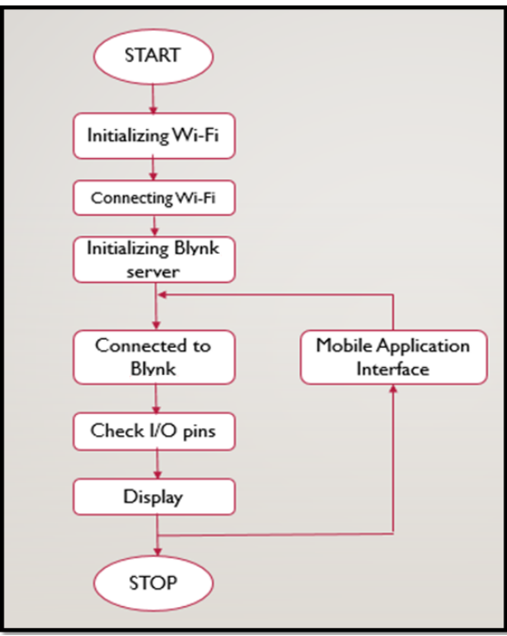

**Fig.- Flow Chart of the Prototype Function.**

This flow chart shows the working of the project. The process starts with initializing the Wi-Fi, the network name and password are written in the code and uploaded to Node MCU. The android device is connected to Node MCU over Wi-Fi. The Blynk server is set up and connection is made, the devices is identified in the Blynk server using the generated authentication token. The command for controlling the load is given to the application, and this command, over Wi-Fi network is sent to the Node MCU.

**5.2 PRINCIPLE AND OPERATION**

Node MCU is an open source IOT platform. It includes firmware which runs on the ESP8266 Wi-Fi SoC from Espressif Systems, and hardware which is based on the ESP-12 module. The term “Node MCU” by default refers to the firmware rather than the development kits. The firmware uses the Lua scripting language. It is based on the eLua project and built on the Espressif Non-OS SDK for ESP8266. It uses many open-source projects, such as lua-cjson, and spiffs.

5.2.1 Advantages of Node MCU

* Low cost, the Node MCU is less costly compared to any other IOT based device.
* Node MCU has Arduino Like hardware I/O. It is becoming very popular in these days that Arduino IDE has extended their software to work in the field of ESP 8266 Field module version.
* Node MCU has easily configurable network API.
* Integrated support for Wi-Fi network: ESP 8266 is incorporated in Node MCU, which is an easily accessible Wi-Fi module.
* Reduced size of board.
* Low power consumption.

**5.2.2 Disadvantages of Node MCU**

* The operation of the circuit depends on the working internet connection. If the working internet connection is not available, then it will not run.
* Node MCU also depends on the free server provided by the third party, if the free server is not working then it will not run.
* Node MCU has less resources of official documentation
* Need to learn a new language and IDE
* Reduced pinout
* Scarce documentation­

**5.3 BLYNK APPLICATION**

The Blynk application was designed for the primary purpose of Internet of Things. Blynk is a platform with IOS and Android apps to control Arduino, Raspberry Pi and the likes over the Internet. It’s a digital dashboard where graphic interface for a prototype can be built by simply dragging and dropping widgets. It can control hardware remotely, it can display sensor data, can store and visualize data and possessed a lot more functionality. There are three major components in the platform:

* **Blynk Application** allows to you create amazing interfaces for your projects using various widgets we provide.
* **Blynk Server** is responsible for all the communications between the smartphone and hardware. You can use our Blynk Cloud or run your private Blynk server locally. It’s an opensource, could easily handle thousands of devices and can even be launched on a Raspberry Pi.
* **Blynk Libraries** for all the popular hardware platforms – enable communication with the server and process all the incoming and outgoing commands.

Every time a radio button is accessed in the Blynk application, the message travels to the Blynk Cloud, where it finds the specific hardware by the unique generated authentication token. It works in the same way for the opposite direction.

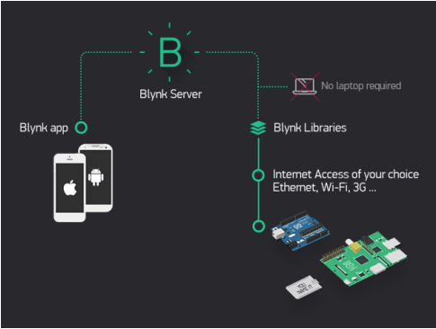

Fig.- Working Principle of Blynk application.

**5.4 WIRELSS COMMUNICATION NETWORK**

The prototype aims to wireless control over home appliances with the technology of IOT. As discussed earlier, IOT supports various wireless communication protocols, like Bluetooth, Z-Wave, Zigbee etc. this prototype uses Wi-Fi as wireless communication network to establish remote access over home appliances. This is because Wi-Fi has its own advantages over other wireless communication protocols.

Advantages of Wi-Fi over other wireless technologies like Bluetooth and ZigBee Bluetooth is generally used for point-to-point networks and Bluetooth operates at a much slower rate of around 720 Kbps which is very small for video transfer or moving large amount of data like the image captured from a camera, whereas the bandwidth of Wi-Fi can be up to 150Mbps and very ideal for video transmission. Wi-Fi is very much secure means of communication than Bluetooth. Wi-Fi connection to send video, audio, and telemetry operation, while accepting remote control commands from an operator who can be located virtually anywhere in the world. Robots are already being eyed for obvious tasks like conducting search-and rescue missions during emergencies or hauling gear for soldiers in the jungle or woods. The mechanics of the robot uses the concept that has been developed to ensure robust navigation, search, and transportation in rough terrain.

**5.5 VOICE MODE CONTROL**

The prototype works in both switch mode and voice mode of control. The switch mode is simply accessing the radio buttons on the Blynk application, and the process of control has been discussed earlier in this chapter in the section before. Here we will discuss the voice mode control of the prototype. We use application IFTTT and Google assistant on smart phone to achieve control by voice commands.

IFTTT stand for ‘If This Then That’, is an interface that provides web-based service in which devices are connected to mobile application. We cannot connect the Google Assistant to the Node MCU directly, and that is the only reason we are using the Blynk app. Blynk app can directly connect to the Node MCU and send data to it. So, if we can send the voice commands interpreted by Google assistant directly to the Blynk app, the Blynk app can then forward those commands to the NodeMCU. But the problem is Google Assistant cannot directly understand foreign commands like “turn on the fan” or “turn on relay one” etc. on its own. So, to solve this we use another intermediate application/website called ‘IFTTT’.

Simply, to control our home appliances over the internet we are using Node MCU and to connect Node MCU with the home appliances we use a relay board. Now to send on or off signals to the Node MCU we use our smartphone, and we do this using the Blynk app. But we want to send the on or off signals using voice commands. To do this we use google assistant in our smartphone and an app called IFTTT. So, in the end what will happen is, when we say a voice command like “ok google turn on the light” to the Google Assistant, Google Assistant sends that this foreign command to IFTTT. IFTTT interprets this command and sends an on or off signal to the Blynk app via the Blynk Server. Blynk will then send this signal to the Node MCU and then to our electrical appliances.

**CONCLUSION AND FUTURE SCOPE**

**6.1 RESULT**

The experimental model was made according to the circuit diagram and the results were as expected. The home appliances could be remotely switched over Wi-Fi network. Both the switch mode and the voice mode control methodologies were successfully achieved. The Blynk application was also successful in displaying the status of every application.

**6.2 LIMITATIONS**

Android devices having lower API version than 16 requires internet access to convert the speech data to string data. Currently, the application is made for Android Smart Phones; other OS platform doesn’t support our application. During voice mode, external noises (voice) may affect our result. The speech instruction that we command in our voice mode may not give exact result as expected. There hence lies an ambiguity in result.

**6.3 FURTHER ENHANCEMENT AND FUTURE SCOPE**

Looking at the current situation we can build cross platform system that can be deployed on various platforms like iOS, Windows. Limitation to control only several devices can be removed by extending automation of all other home appliances. The prototype can include sensors to implement automatic control of the home appliances like; an LDR that can sense daylight and switch lamp accordingly, a PIR to detect motion and be used for security purposes making an alarm buzz, or a DHT11 sensor that’s senses ambient temperature and humidity of atmosphere and switch fan/air conditioner accordingly. Scope of this project can be expanded to many areas by not restricting to only home, but to small offices.

**6.4 CONCLUSION**

It is evident from this project work that an individual control home automation system can be cheaply made from low-cost locally available components and can be used to control multifarious home appliances ranging from the security lamps, the television to the air conditioning system and even the entire house lighting system. And better still, the components required are so small and few that they can be packaged into a small inconspicuous container. The designed home automation system was tested a number of times and certified to control different home appliances used in the lighting system, air conditioning system, home entertainment system and many more. Hence, this system is scalable and flexible.

**REFERENCES**

**1.** **“Smart Energy Efficient Home Automation System using IOT”**, by Satyendra K. Vishwakarma, Prashant Upadhyaya, Babita Kumari, Arun Kumar Mishra.

**2.** **“IOT Based Smart Security and Home Automation”**, by Shardha Somani, Parikshit Solunke, Shaunak Oke, Parth Medhi, Prof. P. P. Laturkar.

**3.** **“A Dynamic Distributed Energy Management Algorithm of Home Sensor Network for Home Automation System”**, by Tui-Yi Yang, Chu-Sing Yang, Tien-Wen Sung; in 2016 Third International Conference on Computing Measurement Control and Sensor Network.

**4.** **“Enhance Smart Home Automation System based on Internet of Things”**, by Tushar Churasia and Prashant Kumar Jain; in Proceedings of the Third International Conference on I-SMAC (IoT in Social, Mobile, Analytics and Cloud) (I-SMAC 2019) IEEE Xplore Part Number: CFP19OSVART; ISBN:978-1-7281-4365-1

**5. “Visual Machine Intelligence for Home Automation”**, by Suraj, Ish Kool, Dharmendra Kumar, Shovan Barman.

**6. “A Low Cost Home Automation System Using Wi-Fi based Wireless Sensor Network Incorporating internet of Things”**, by Vikram.N, Harish.K.S, Nihaal.M.S, Raksha Umesh, Shetty Aashik Ashok Kumar; in 2017 IEEE 7th International Advance Computing Conference.

**7. “Voice Controlled Home Automation System using Natural Language Processing and Internet of Things”**, by Mrs. Paul Jasmin Rani, Jason Bakthakumar, Praveen Kumaar.B, Praveen Kumaar.U, Santhosh Kumar; in 2017 Third International Conference on Science Technology Engineering & Management (ICONSTEM)

**8. Wikipedia (2009). Home Automation**. From https://en.wikipedia.org/wiki/Home_automation 9. Theory of IOT from :https://internetofthingsagenda.techtarget.com/definition/Internet-of-Things-IoT

**10. About Node MCU** from: https://lastminuteengineers.com/esp8266-nodemcu-arduino-tutorial/